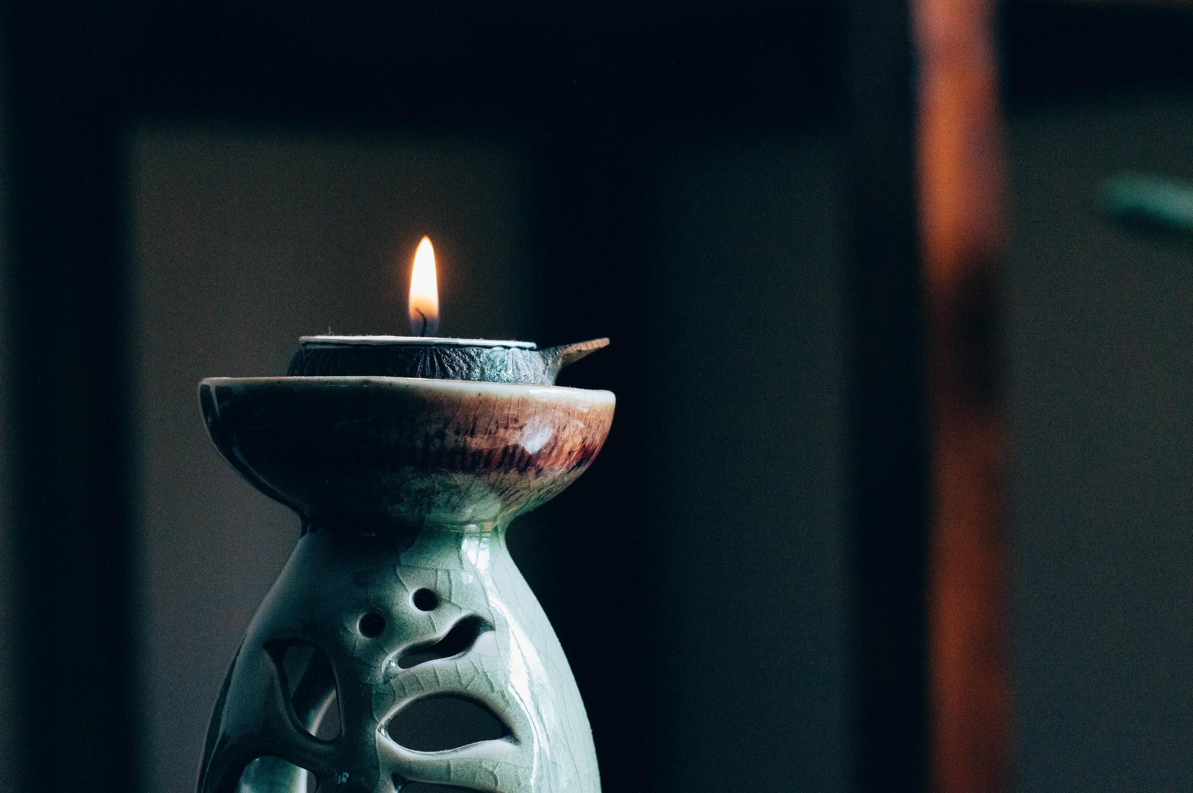
Photo by Hans Vivek on Unsplash

Healing with Mindfulness: How Yoga and Meditation Helps Seniors and Caregivers

According to the Pew Research Center, there are 40.4 million unpaid caregivers of adults ages 65 and older in the United States. Caregiving involves some financial and medical support, but a big part of it is being there for a senior loved one on an emotional level. If a caregiver notices signs of mental illness in a senior, they should talk to them and their doctor about possible treatments. Their physician may prescribe medication and therapy, but generally, all doctors agree that certain lifestyle changes are necessary for treating mental illness.

One of these lifestyle changes is adding exercise into the daily routine. Caregivers can easily incorporate exercises with technology like YouTube exercise videos, fitness apps, and Wii games, but these keep both parties cooped up inside. By combining socialization with exercise, caregivers can facilitate a sense of community and help prevent senior loneliness. Yoga and meditation groups for seniors provide a supportive community while teaching exercise and mindfulness that is beneficial for both parties.

Benefits of Yoga for Seniors and Caregivers

Yoga originated in ancient India, but it’s evolved into a worldwide phenomenon. There are various types of yoga practices to choose from:

- Hatha yoga - a classic approach to breathing and poses
- Iyengar yoga - slow, methodical, often uses props
- Kundalini yoga - incorporates chanting, mantra, and meditation
- Ashtanga yoga - physically demanding sequence of postures
- Vinyasa yoga - the most athletic yoga style
- Bikram yoga - aka “hot yoga,” room is set to 105 F with 40 percent humidity
- Yin yoga - slow-paced style of yoga with seated postures
- Restorative yoga - focuses of full body relaxation
- Prenatal yoga - helps moms-to-be prepare for birthing
- Anusara yoga - focuses on the mind-body-heart connection
- Jivamukti yoga - vinyasa flow-style classes infused with Hindu spiritual teachings

Finding the right class takes a bit of trial and error, but seniors can benefit particularly from gentler classes such as kundalini, yin, and restorative yoga. Some studios have their instructors design hatha classes with limited mobility in mind. Finding a class specifically for seniors helps them and their caregivers seamlessly integrate into a community that is empathetic to their situation. Attending these classes gets seniors and caregivers out of the house while improving physical, mental, and emotional health.

Benefits of Meditation for Seniors and Caregivers

Yoga involves focusing on the breath and being in the moment, but it doesn’t improve mindfulness quite as well as a pure meditation. Meditation is extremely beneficial for seniors and their caregivers, as it improves mental focus and an enhances the mind’s ability to concentrate on the moment. Regular meditation shields the brain from the effects of stress and anxiety. Meditation helps both seniors and their caregivers cultivate a greater sense of well-being and diminishes symptoms of anxiety and depression. For seniors, meditation can reverse early memory loss due to Alzheimer’s disease and the onset of dementia. According to a study involving 49 caregivers, regular meditation reduces symptoms of depression, boosts mental health, and improves the durability of immune cells with increased telomerase activity.

Meditation can be practiced anywhere and at any time, but many people find that practicing group meditation is a rewarding experience. When meditating as a group, each individual’s energy frequency attunes to those around them. This enhances concentration and helps facilitate feelings of well-being for everyone in the room. Of course, spending some time out of the house helps both seniors and their caregivers alleviate stress due to isolation.

Millions of Americans care for senior loved ones when they can no longer care for themselves. While part of caregiving is providing financial and medical support, a more important part is being there for seniors emotionally. Incorporating yoga and meditation into schedules provides an outlet for stress and anxiety, which can help prevent the development of mental illness. Furthermore, the community that exists at yoga classes and group meditation can help alleviate anxiety and loneliness in seniors and their caregivers.

